Directions for creating a Jeopardy game:

Open the Jeopardy template at http://teach.fcps.net/trt10/Documents/jeopardytemplate25.ppt

Before you begin, let’s save it with a different name so that you don’t replace the template with your new game. To do this, click FILE and then SAVE AS (not save) and rename it from jeopardy template 25.ppt to whatever the topic of this game is.
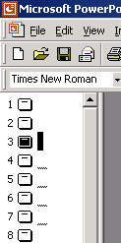
Click on Slide #4 on the left side of the window.

You will then see the board with the categories and choices. Click once on the words “Category A”.
When you see the text box appear you can highlight
that text and type in your replacement. Do this for each of the category headings.

Then click on the Slide 5 and in the same manner as above, replace that text with the Answer (remember this is jeopardy, we give the students the answer and have them give us the question in return) that you want to be the 10 point answer for the first category.

Listed below are the slide numbers as they match up to the categories so that you can match the answers and questions on the appropriate slides.

Category | Amount of Points | Answer Slide # | Question Slide #
One (1A) | 10 | 5 | 6
One (2A) | 20 | 7 | 8
One (3A) | 30 | 9 | 10
One (4A) | 40 | 11 | 12
One (5A) | 50 | 13 | 14
Two (1B) | 10 | 15 | 16
Two (2B) | 20 | 17 | 18
Two (3B) | 30 | 19 | 20
Two (4B) | 40 | 21 | 22
Two (5B) | 50 | 23 | 24
Three (1C) | 10 | 25 | 26
Three (2C) | 20 | 27 | 28
Three (3C ) | 30 | 29 | 30
Three (4C) | 40 | 31 | 32
Three (5C) | 50 | 33 | 34
Four (1D) | 10 | 35 | 36
Four (2D) | 20 | 37 | 38
Four (3D) | 30 | 39 | 40
Four (4D) | 40 | 41 | 42
Four (5D) | 50 | 43 | 44
Five (1E) | 10 | 45 | 46
Five (2E) | 20 | 47 | 48
Five (3E) | 30 | 49 | 50
Five (4E) | 40 | 51 | 52
Five (5E) | 50 | 53 | 54
Final Jeopardy | Wager | 56 | 57

Be sure to save what you have done. (Since we’ve already saved it when we began, this time you can just hit the save button on the toolbar.)

Then go back and play the game yourself (by clicking on “View Show” in the “Slide Show” menu) to make sure that the correct answers and questions are together. Note: When running the game, to go from the answer slide to the question side or back to the game board, click somewhere in the blue border of the slide.

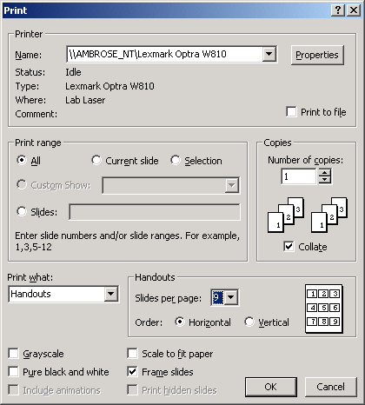
I would also print out a master copy for you to use as the students are playing the game. An easy way to do this and still save paper is to select FILE and PRINT. Then when you see this window, at the bottom select Handouts and 9 slides per page. This way you will not be printing 56 slide all on an individual sheet.

As always, if you have any questions, please feel free to email me.

Kim Overstreet
koverstr@fayette.k12.ky.us

